HTML-HANDSON.1

## The first thing I did was create a new file then I changed the title into “HTML HANDSON1. Then I added some styles like : width and border-collapse on the table.

## While added width and padding on the table row,table-head and table-data.

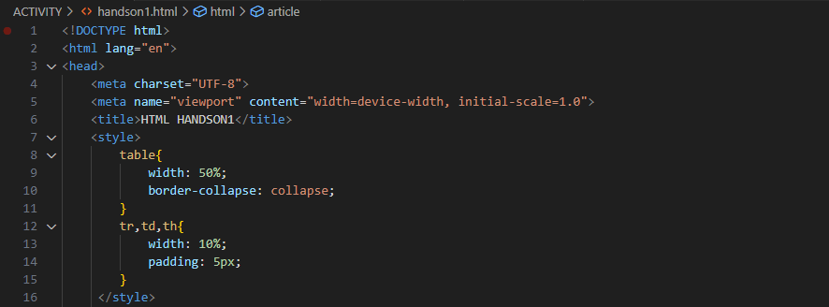

## 

## I added a header, and wrote “HTML TABLE”. Then, I started creating the table by adding some styles on the table-heads and table-rows.

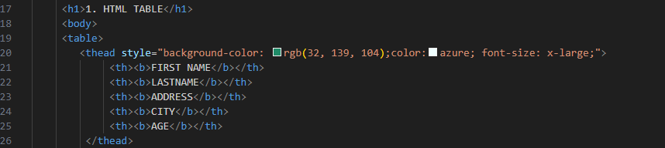

OUTPUT:

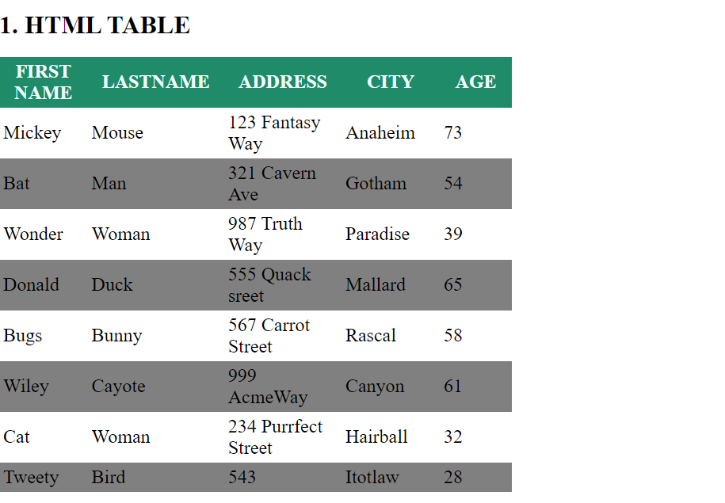

## 

## After that, I created a section then inside the section I created the new table with the same data as the previous one, but this time with an image,so I browsed some photos from the internet. I didn’t have a hard time this time. Because I know that I am learning some codes everyday.

## 

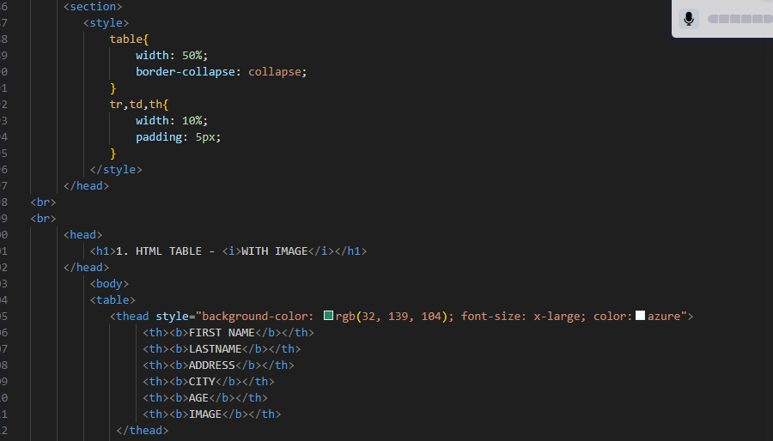

OUTPUT:

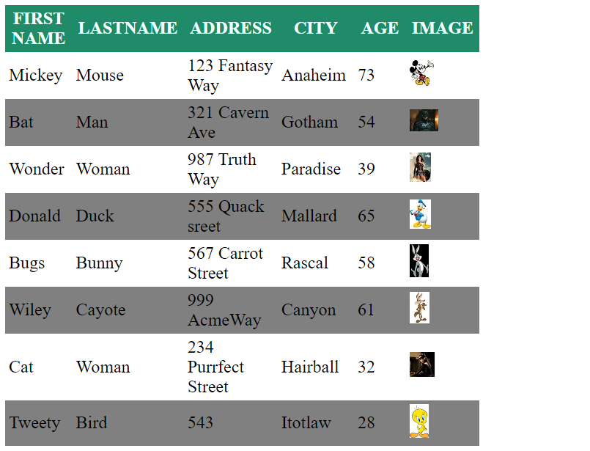

## Then the next thing I did was create a list of my top 3 restaurants. I copied the link address of their website then added attributes.Added a breaker again and section.

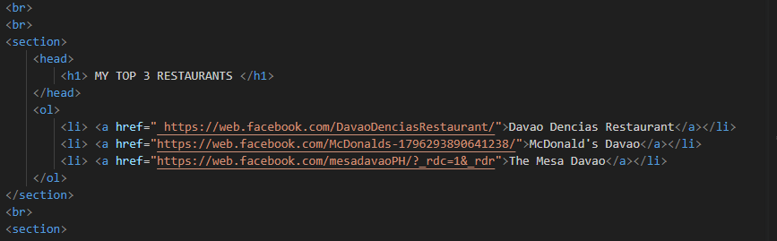

OUTPUT:

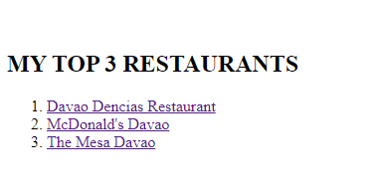

## In this section I added a header again for my unordered list of Top 5 Colors.I changed the font-color of each color-name.

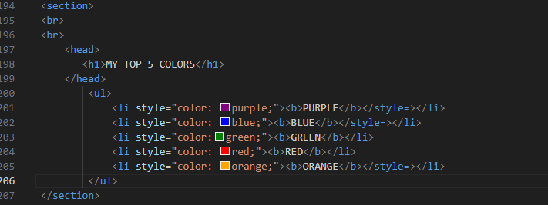

OUTPUT:

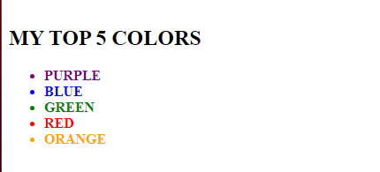

## And then I created a short article. Inside an article is a header and paragraph.

OUTPUT:

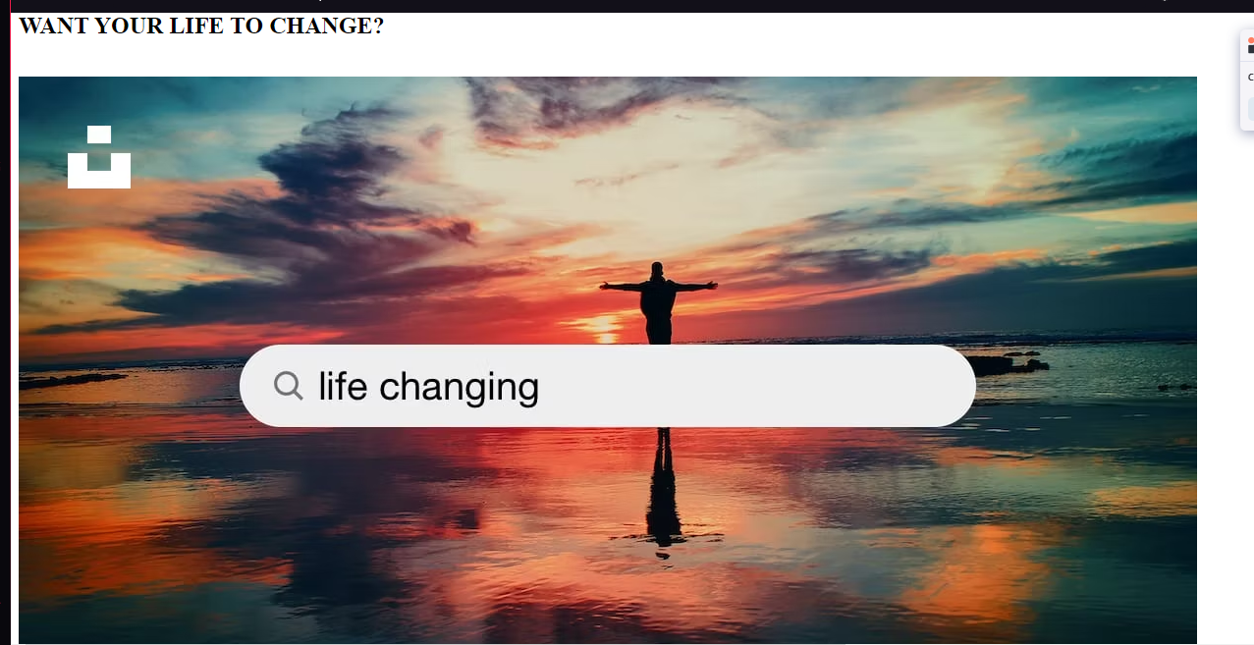

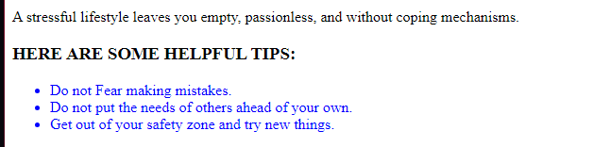

## I embedded my favorite music video from youtube. Walong Bilyon, sang by TJ Monterde.

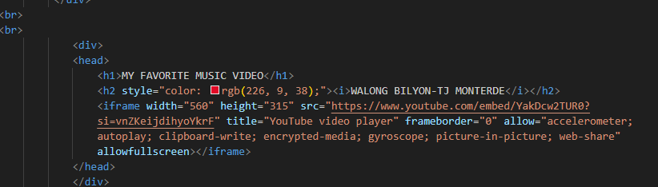

0UTPUT:

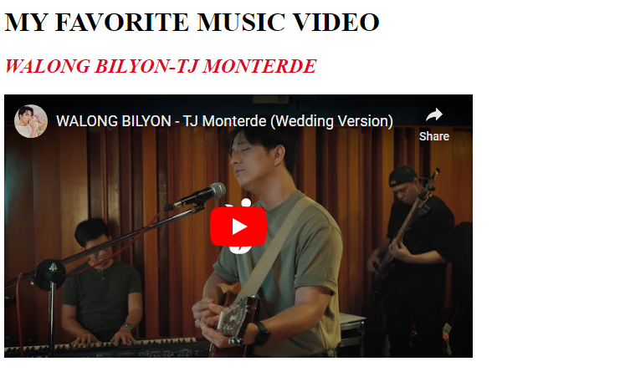

## Moving on to the last part, I embedded the location of my favorite hang-out place. Since I watched the zoom recordings I didn’t have a hard time doing it.

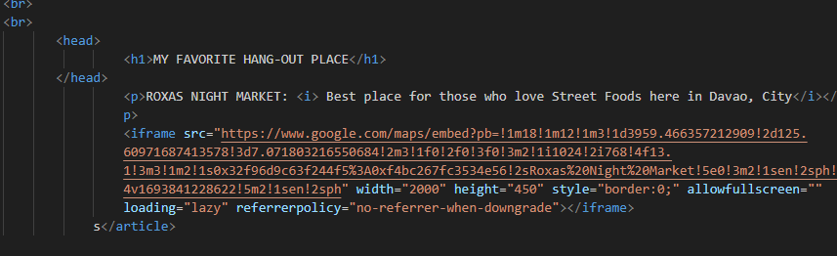

OUTPUT:

